WIND POWER INTEGRATION INTO ELECTRICITY SYSTEMS
Student’s name
Institution name
Instructor’s name
Course title
Date

Most of those countries that have developed are mainly after making sure that their citizens live well by lowering drugs' prices through what is known as price control. Most big pharmaceutical companies in the United States are mainly into business without looking if it will benefit them. Even though the drugs are essential, the prices should not be very high. There should be a common price that can easily be affordable to many. Pharmaceutical companies are busy producing the drugs and supplying them while those who can purchase are meager. Instead of making its people go through a lot while they are sick, it will be something good for most countries to come up with free healthcare services to benefit the people. The more people have access to free healthcare facilities, the number of deaths will be greatly reduced, which will be a plus to the country. Once the country tries to ignore its citizens, it is evidence that the majority will suffer apart from the few who will try to rescue themselves out of that situation.
Some other countries have set strong measures to ensure that the people easily access the healthcare system, which is the right channel that most countries should take if they wish to make things work for their pharmaceutical companies. Live of the people above all matters a lot, and ensuring the citizens are protected is proud. Citizens with better medical attention will, in most of the case, be happy with what the country is doing as compared to those people who struggle to live. Pharmaceutical companies will benefit the population if the government takes up the initiative of making sure that the prices and the drugs that are sold are all following the act (Takruri, 2014). It will be something great if the United States government comes up with a board that will ensure that the pharmaceutical companies are not taking advantage of the consumer's rights. Adding the United States should also ensure that any new drug that comes into the market doesn't have a higher price than the median price worldwide. They should take up the role of making sure that such drugs' prices don't vary a lot from what other countries are paying. As it stands, Canada is doing all the above, which is actually very different from what is being done in the United States.
In the United States, it is estimated that the people are paying for the drugs 16 times the same drugs' prices in other countries. As compared to Canada, the united states are considered to have an excellent economy, yet Canada is doing everything possible to ensure that their citizens benefit the most from the pharmaceutical companies, and there is no excuse for this difference (Valverde, 2012). It is true that instead of the people being given more power, the corporations have a lot of power, which goes against the preamble. From this evidence, it is true to state that the prices of drugs in the United States are high without adverse effects.
It is true that with the big pharmaceutical companies no having control over the prices, most of the people are mainly suffering from the same, and this has brought harm to the medical patients. If the patients cannot purchase the drugs prescribed to them, this may negatively impact the patients, and thus it is only possible for them to respond positively if they can get the drugs they want. The only solution to avoid all these issues is for the United States to make sure that the big pharmaceutical companies control the prices. Coming up with a board will be the best thing that the government can do to weigh the different prices of drugs from different places worldwide. Live of the people matter a lot in a nation, and it is the country's mandate to make sure that they are always there in trying to protect the rights and lives of those people. Health care is a sensitive area, and thus it requires a lot of attention if the country wants to keep up the pace of patient recovery.
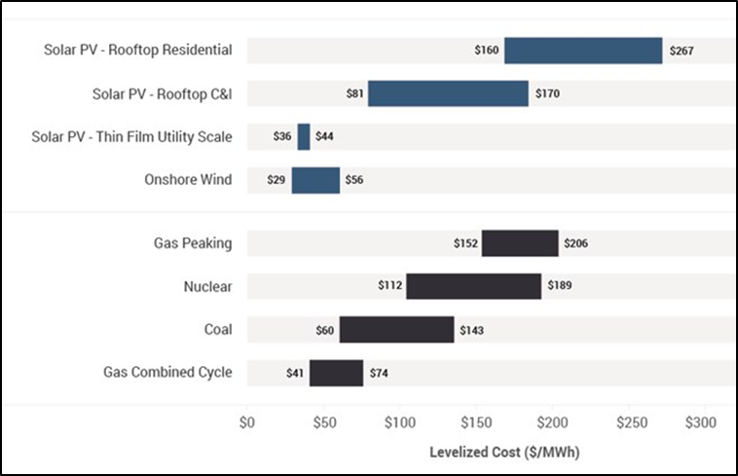
Despite the low ongoing cost, the initial cost of setting up a wind power plant is expensive compared to conventional energy. It can be 75–85 percent of the total project cost, including the connection of the grid, foundation, construction site transport, and the turbine costs (Kumar et al. 215). As of 2018, the overnight capital cost or the cost of building a wind power plant overnight comes around $1,624 per kW than gas or oil, which costs $794 per kW (U.S Energy Information Administration). These figures show that a wind power plant costs more than a gas or oil power plant.
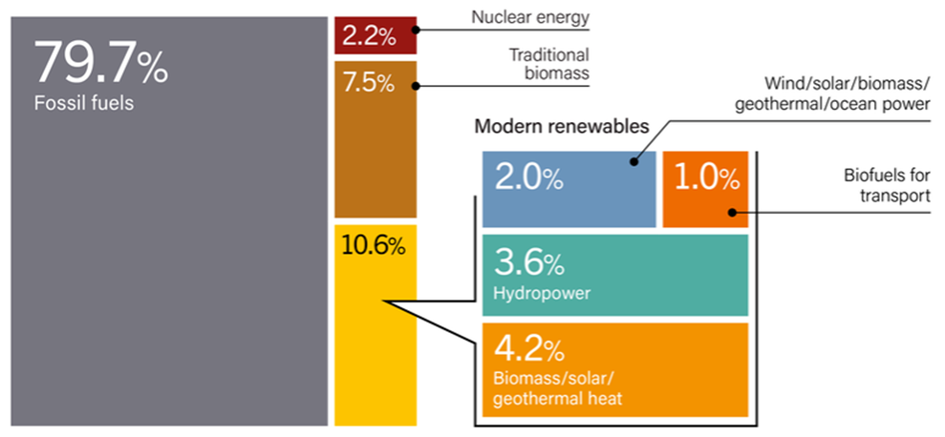
The high entry cost requires a large-scale investment from the share market, and its biggest challenge comes from the market competition. Based on the Renewables 2019 Global Status Report, WE's estimated shares are lower than 2 percent of the global share (see fig. 2). These numbers are meager compared to fossil fuel, which acquired nearly 80 percent of the market. Coal, natural gas, and oil companies dominated the market as they are funded heavily by the governments through governmental policies such as subsidies, tax credits, and other incentives. Understandably, they do so because the fossil fuel industry and fossil fuel technologies are mature and more reliable. Equally important, companies favoring non-renewable energy make arguments such as the variability of wind and storage issues as a way to shift investors' attention to coal, gas, and nuclear plants (Union of Concerned Scientists). Along with a lack of experience in this industry by financial institutions, this makes obtaining fund tougher (Clarke 750). Since the electricity generated relies on wind speeds, the speeds cannot be anticipated with high precision as the wind often fluctuates between minutes and hours.
Therefore, planners and operators of electrical utility systems are worried that the wind plant's variations may increase the plant's operating cost. In trying to solve the issue, most of the planners and the operators are trying their best to make sure that they find a solution to these and save the operating cost instead of increasing the cost. The best way to make people embrace wind power energy for the generation of electricity is by making it cheaper and affordable to the people. This will ensure that the people are ready to test the wind power energy for electricity generation (Ibrahim et al. 819). Unlike renewable energy, fossil fuels are readily available and transportable, meaning they can operate on-demand. Although this is true to some extent, WE technology has matured through sophisticated engineering development, such as turbine efficiency (Clarke 744). Not only that, a lot of Research and Development (R&D) has been made to enhance grid efficiency.
To overcome the market barrier, WE need assistance specifically from the government. Governments play a huge role in equaling the playing fields by providing subsidies or tax exemptions to WE technologies and investing in the research and development of WE (Clarke 748). Two ways of employing subsidies are, by all means, reducing the capital cost and paying a premium price for electricity. They should also clarify the standards and regulations for WE to provide a guaranteed market for WE technology.
Geographical constraints become an important factor that causes stagnant growth where sites are limited through other land-uses and due to environmental impacts. Good winds are usually situated far away from electricity-required towns. This leads to a longer transmission line, increased travel costs, and the maintenance of the turbines in remote locations (Kumar et al. 220). Additionally, it requires arrangements, agreements, licenses, and network relations, all of which can build expenses and deferral or execute ventures. Although wind power plants benefit the economy in rural areas, they do not outweigh the increase in capital cost. For instance, ranchers and farmers can keep working since wind turbines utilized just a small amount of the ground (Office of Energy Efficiency and Renewable Energy). Wind turbine proprietors pay the rancher or farmer lease to utilize the property, giving landowners extra revenue. The environmental impact of turbines' spinning forbids companies to build wind plants near residential or urban areas. Whereas wind turbines have a little ecological impact than conventional power plants, the noise from turbine blades and the landscape's visual effect remains a problem. The sound produced by wind turbines is not usually noisy in terms of noise pollution (Kumar et al. 221). Turbines, for instance, generate less noise than road traffic on a highway. However, this noise can be heard at long distances in certain circumstances. Persistent noise could lead to health issues such as sleeping disorders, anxiety, and stress. In terms of aesthetic, there is some evidence that the flickering and shifting shade of the rotating turbine may have negative health impacts, such as stress, discomfort, and photo-sensitive epilepsy (such a neurological sickness in which seizures are brought about by visual upgrades, for example, moving examples, blazing lights, and shadows) (Kumar et al. 221). Compared to power plants that rely on fossil fuels' combustion, WE are clean and safe for the environment. On the other hand, conventional energy produces air discharges that cause corrosive downpour, brown haze, or ozone harming substances and particulate matter that causes human health problems.
One of the ways to overcome this geographical barrier is to build offshore wind energy. Not only the visual and noise impact can be ignored, but the stronger and consistent wind at sea can also provide greater productivity (Leung and Yang 1035). However, Leung and Yang claim that the expense of developing a seaward wind ranch is twofold the cost that inland, similar to the pinnacles, establishments, submerged cabling, and establishment are more troublesome and costly. Moreover, offshore wind turbine technology's reliability needs to be studied and proven to deal with the harsh environment (1036).
In conclusion, even though WE may have its disadvantages, such as its struggle to diffuse into the current energy market and the restricted building sites, its advantages, such as its low operating costs, is more superior and beneficial enough to outweigh its shortcomings. Through investments, WE can tap into its full potential by installing advanced technology and the implementation of large and expensive transmission networks. Although it is environmentally friendly, its minor environmental impacts on humans should not be overlooked. It can bring harm in the long run due to its great potential development in usage. Regardless, the advancement of WE technology is crucial in building a safe and sustainable future for our planet. Global phenomenon harming our planet such as global warming, forest fires, droughts, ice melts will continue to happen if we continue with our current method of producing energy by burning fossils fuels.
With the way things are going, it is clear that most countries should try to make efforts to realize wind power energy in trying to incorporate it in the electricity system. Most countries are spending a lot of fuel, causing some major population in the environment. With clear goals and objectives, they can try and make the world a better place to live. The best way that the country can schedule itself in trying to make it end well is through coming up with the budget that will best suit the wind power project and making sure that they push the idea in making the people try to understand the benefit of using the wind power for electricity generation instead of focusing a lot on the fossil fuel which may cause a lot of issues in the future.

Works Cited
Clarke, Alexi. “Wind energy progress and potential”. Energy Policy, vol.19, no. 8, 1991, pp.742- 755. Elsevier BV, doi:10.1016/0301-4215(91)90044-o.
Ibrahim, Hussein, et al. “Integration of Wind Energy into Electricity Systems: Technical Challenges and Actual Solutions”. Energy Procedia, vol. 6, 2011, pp. 815-824. Elsevier BV, doi:10.1016/j.egypro.2011.05.092. Accessed 27 June 2019.
Kumar, Yogesh, et al. “Wind energy: Trends and enabling technologies”. Renewable and Sustainable Energy Reviews, vol. 53, pp. 215-221. Elsevier BV, doi:10.1016/j.rser.2015.07.200. Accessed 27 June 2019.
Lazard, Levelized Cost of Energy and Levelized Cost of Storage 2018, 8 November 2018, https://www.lazard.com/perspective/levelized-cost-of-energy-and-levelized-cost-of-storage-2018/. Accessed 27 June 2019.
Leung, Dennis Y.C., and Yuan Yang. "Wind Energy Development And Its Environmental Impact: A Review". Renewable And Sustainable Energy Reviews, vol 16, no. 1, 2012, pp. 1031-1039. Elsevier BV, doi:10.1016/j.rser.2011.09.024. Accessed 27 June 2019.
Office of Energy Efficiency & Renewable Energy, Advantages and Challenges of Wind Energy, https://www.energy.gov/eere/wind/advantages-and-challenges-wind-energy. Accessed 27 June 2019.
Renewables 2019 Global Status Report. REN21 Renewables Now, 2019, https://www.ren21.net/gsr-2019/chapters/chapter_01/chapter_01 /. Accessed 27 June 2019.
Union of Concerned Scientists. Barriers to Renewable Energy Technologies. https://www.ucsusa.org/clean-energy/renewable-energy/barriers-to-renewable-energy#.W4_-J-hKi00. Accessed 27 June 2019.
U.S. Energy Information Administration, eia.gov, January 2019, https://www.eia.gov/outlooks/aeo/assumptions/pdf/table_8.2.pdf. Accessed 27 June 2019.

